**Course One**

# Foundations of Data Science



# Instructions

Use this PACE strategy document to record decisions and reflections as you work through this end-of-course project. You can use this document as a guide to consider your responses and reflections at different stages of the data analytical process. Additionally, the PACE strategy documents can be used as a resource when working on future projects.

# Course Project Recap

Regardless of which track you have chosen to complete, your goals for this project are:

* Complete the PACE Strategy Document to plan your project while considering your audience members, teammates, key milestones, and overall project goal.
* Create a project proposal for the data team.

# Relevant Interview Questions

Completing this end-of-course project will empower you to respond to the following interview topics:

* As a new member of a data analytics team, what steps could you take to get 'up to speed' with a current project? What steps would you take? Who would you like to meet with?
* How would you plan an analytics project?
* What steps would you take to translate a business question to an analytical solution?
* Why is actively managing data an important part of a data analytics team's responsibilities?
* What are some considerations you might need to be mindful of when reporting results?

**Reference Guide**

This project has three tasks; the following visual identifies how the stages of PACE are incorporated across those tasks.

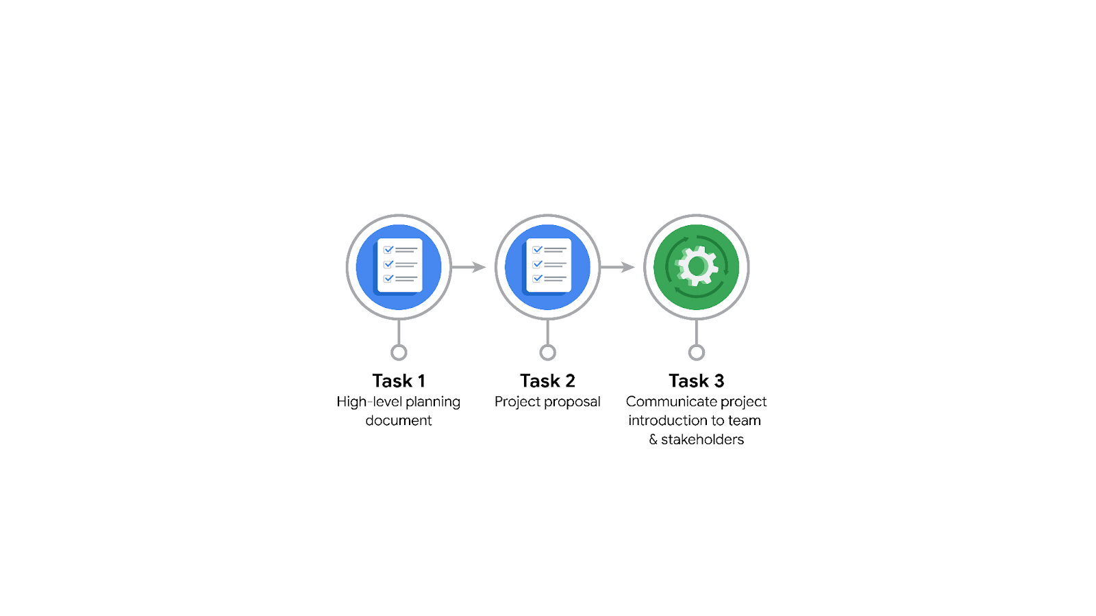

**Data Project Questions & Considerations**

**PACE: Plan Stage**

* Who is your audience for this project?

The audience for this project is the Waze leadership team, which includes executives and stakeholders who are responsible for making strategic decisions regarding user retention and business growth.

* What are you trying to solve or accomplish? And, what do you anticipate the impact of this work will be on the larger needs of the client?

The main objective of this project is to develop a machine learning model that predicts user churn in the Waze app. By accurately identifying users who are at high risk of churning, Waze can proactively engage with them and implement strategies to retain them, thus improving user retention and overall business growth. The anticipated impact of this work is to increase user satisfaction, enhance the user experience, and make data-driven decisions to optimize the company's retention strategy and product development.

* What questions need to be asked or answered?

Who are the users most likely to churn? Identifying the user segments with a higher probability of churning can help target retention efforts more effectively.

Why do users churn? Understanding the factors that contribute to user churn will enable Waze to address those issues and implement targeted interventions.

When do users churn? Determining the timing or patterns of user churn can provide insights into specific triggers or events that lead to churn.

* What resources are required to complete this project?

Access to Waze's user data, including relevant user behavior, engagement, and app usage information.

Computational resources for data analysis, model training, and evaluation.

Expertise in data analysis, machine learning, and statistical techniques.

Collaborative tools for communication and coordination within the data team and with other stakeholders.

* What are the deliverables that will need to be created over the course of this project?

A project proposal outlining the goals, milestones, and tasks for the data team.

Exploratory data analysis (EDA) report, providing insights and summary statistics about the user data.

A trained machine learning model that predicts user churn.

Model evaluation metrics and analysis, assessing the performance and effectiveness of the churn prediction model.

Documentation and presentation materials summarizing the project findings, including main talking points for the leadership team.

## **THE PACE WORKFLOW**



**[Alt-text: The PACE Workflow with the four stages in a circle: plan, analyze, construct, and execute.]**

You have been asked to demonstrate for the company's data team how you would use the PACE workflow to organize and classify tasks for the upcoming project. Select a PACE stage from the dropdown buttons. A few tasks involve more than one stage of the PACE workflow. Additionally, not every workplace scenario will require every task. Refer back to the Course 1 end-of-course portfolio project overview reading if you need more information about the tasks within the project.

### 

### **Project tasks**

Following are a group of tasks your company’s data team has determined need to be completed within this project. The data analysis manager has asked you to organize these tasks in preparation for the project proposal document. First, identify which stage of the PACE workflow each task would best fit under using the drop down menu. Next, give an explanation of why you selected the stage for each task. Review the following readings to help guide your selections and explanation: [The PACE stages](https://www.coursera.org/learn/foundations-of-data-science/supplement/4OtHr/the-pace-stages) and [Communicate objectives with a project proposal](https://www.coursera.org/learn/foundations-of-data-science/supplement/79Ysh/communicate-objectives-with-a-project-proposal). You will later reorder these tasks within a project proposal.

1. **Evaluating the model:** Execute

Why did you select this stage for this task?

Similar to Automatidata

1. **Conduct hypothesis testing:** Analyze **and** Construct

Why did you select these stages for this task?

Similar to Automatidata

1. **Begin exploring the data:** Analyze

Why did you select this stage for this task?

Similar to Automatidata

1. **Data exploration and cleaning:** Plan **and** Analyze

Why did you select these stages for this task?

Similar to Automatidata

1. **Establish structure for project workflow (PACE):** Plan

Why did you select this stage for this task?

Similar to Automatidata

1. **Communicate final insights with stakeholders:** Execute

Why did you select this stage for this task?

Similar to Automatidata

1. **Compute descriptive statistics:** Analyze

Why did you select this stage for this task?

Similar to Automatidata

1. **Visualization building:** Analyze **and** Construct

Why did you select these stages for this task?

Similar to Automatidata

1. **Write a project proposal:** Plan

Why did you select this stage for this task?

Similar to Automatidata

1. **Build a regression model:** Analyze **and** Construct

Why did you select this stage for this task?

Similar to Automatidata

1. **Compile summary information about the data:** Plan

Why did you select this stage for this task?

Similar to Automatidata

1. **Build machine learning model:** Construct

Why did you select this stage for this task?

Similar to Automatidata